1. Login to the AWS Management Console.

Goto **EC2 Dashboard > Running** Instances and search for **Cluster** in the **N.Virginia** Region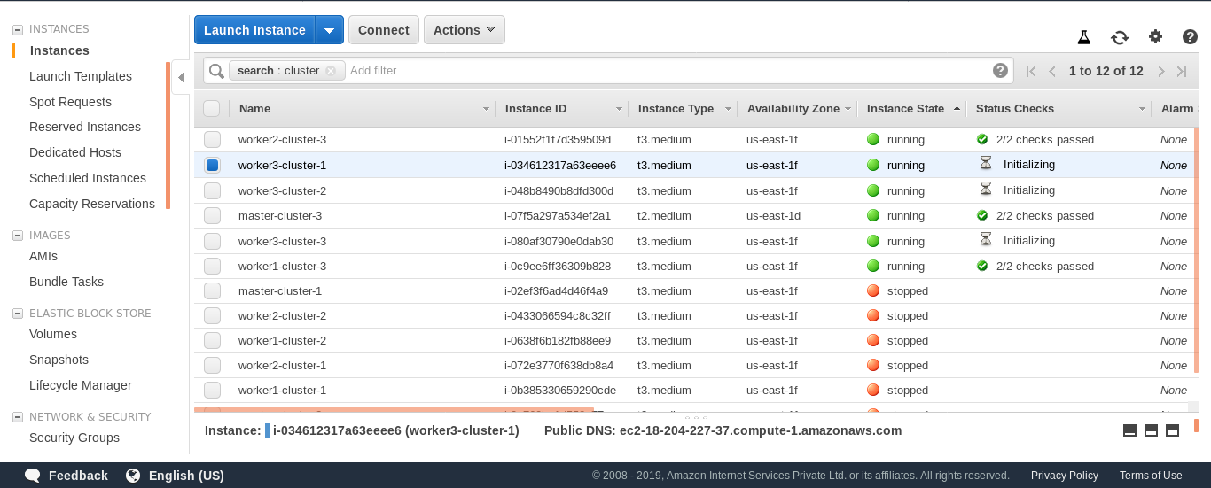

There are 3 Clusters running on with One master and 3 Worker Nodes.

Cluster-1 ( **master-cluster-1 , worker1-cluster-1 , worker2-cluster-1 , worker3-cluster-1** )

Cluster-2 ( **master-cluster-2 , worker1-cluster-2 , worker2-cluster-2 , worker3-cluster-3** )

Cluster-3 ( **master-cluster-3 , worker1-cluster-3 , worker2-cluster-2 , worker3-cluster-3** )

2. SSH to either **master-cluster-1 or master-cluster-2 or master-cluster-3.**

**TO Access the Dashboard SSH to any of the master** instance and run the below command

|  |
| --- |
| $ sudo su (password is Dev0p$!!/) # kubectl get po -n kube-system -o wide |

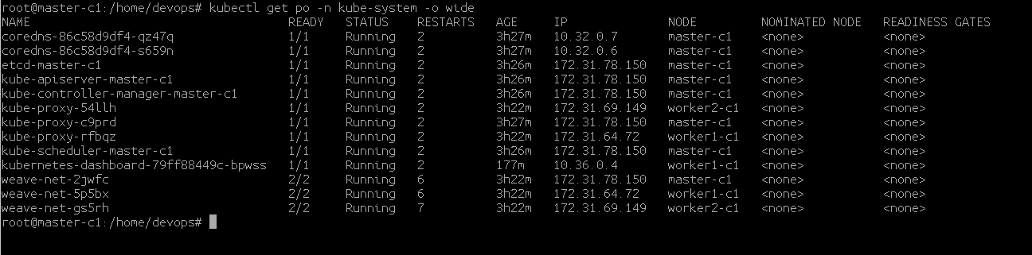

3. Check on which NODE the kubernetes-dashboard-xxxxx pod is running. For Cluster-1 it is

running on **worker1-c1 i.e the worker1-cluster-1**

4. Check the NODEPORT of the Kubernetes Dashoard service.

|  |
| --- |
| # kubectl get svc -n kube-system |

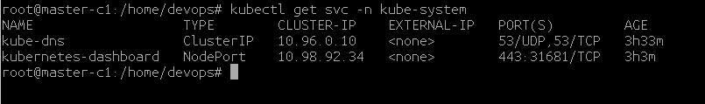

The NODEPORT is **31681**

**5. Access the Dashboard over the Public-IP of the worker1-cluster-1 on port 31681**

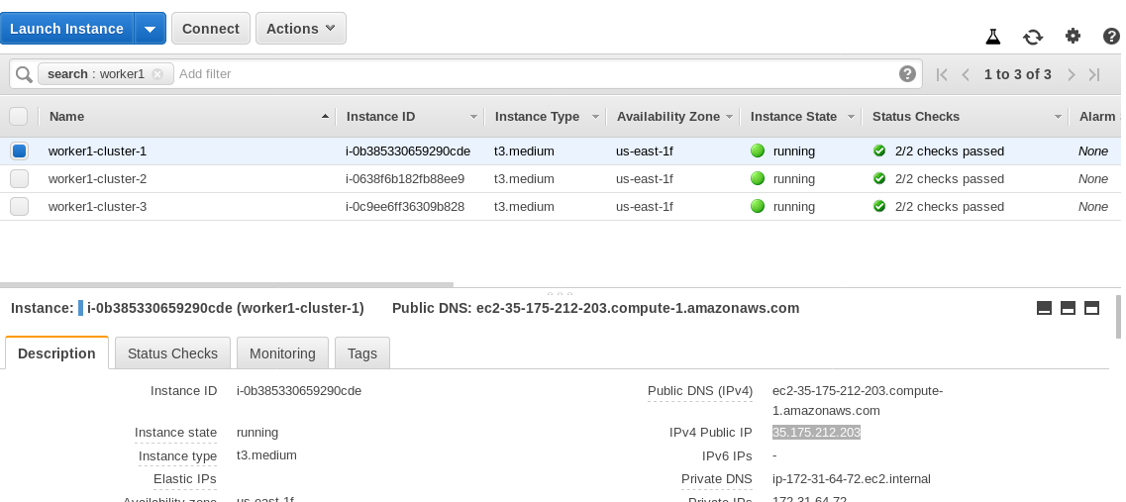

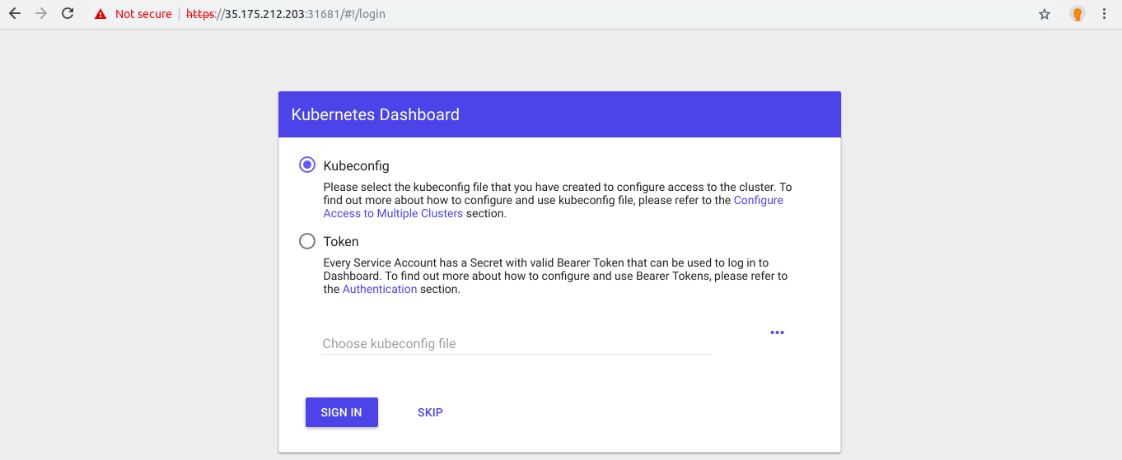

Click on **SKIP** button to login.

6. Similarly you can access Dashboard for **Cluster-2** and **Cluster-3**